**GIT TUTORIALS – PART 1**

1. **Basics:**

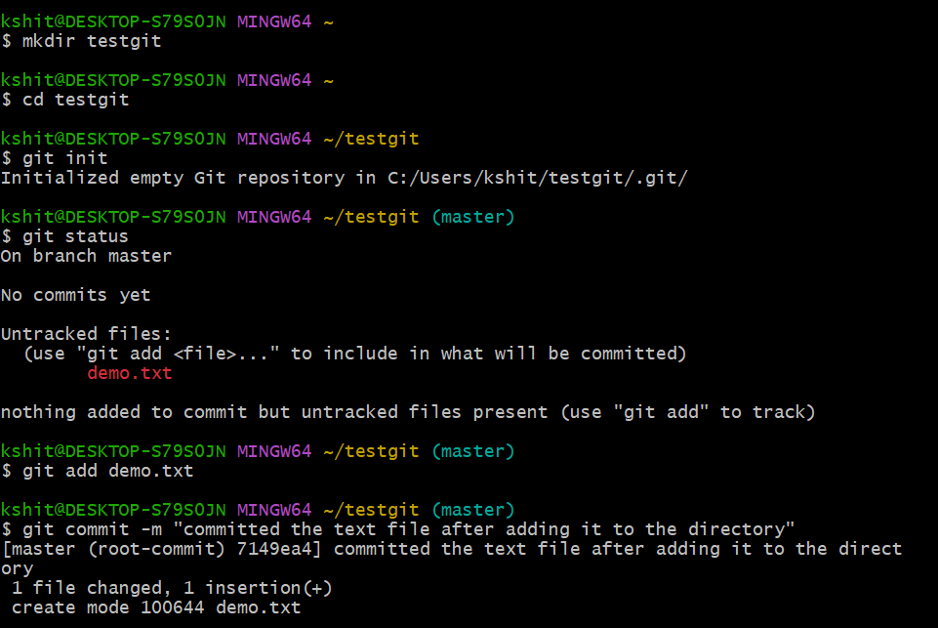

1. **Link GIT with GITHUB (chrome):**



1. **Link remote(github repo) and local repository(git repo):**

* Create a new repository on GitHub as usual.
* Copy the link of the new repository from GitHub.

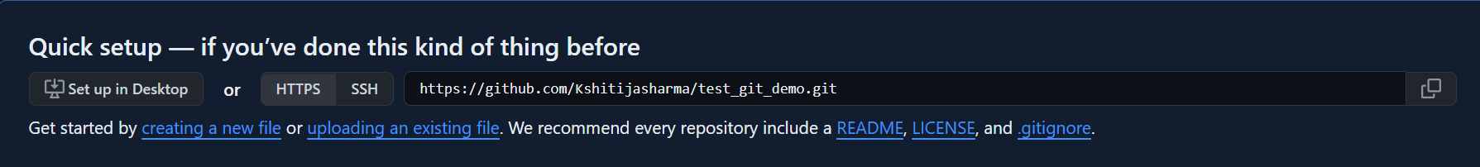



1. **Push the demo file onto the remote repo:**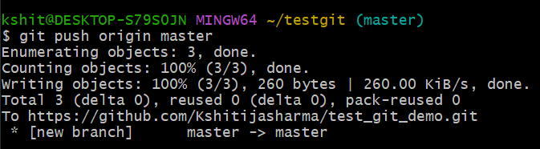

**RESULT:**

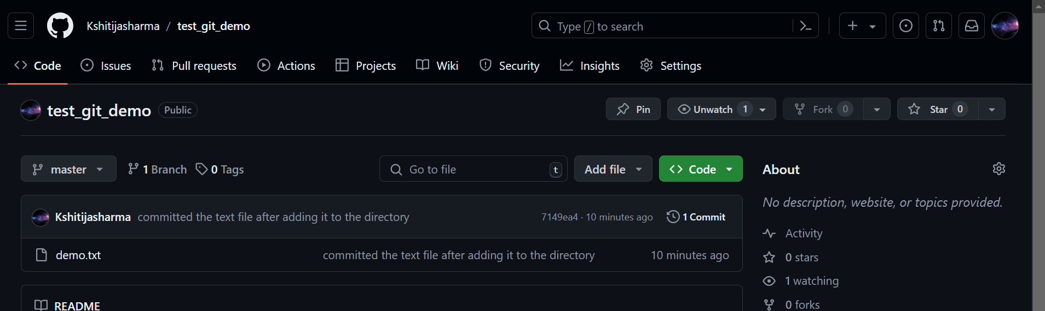

**DEMO ON GIT – PART 2**

1. **Command will tell the difference between two files (that is after changes).**

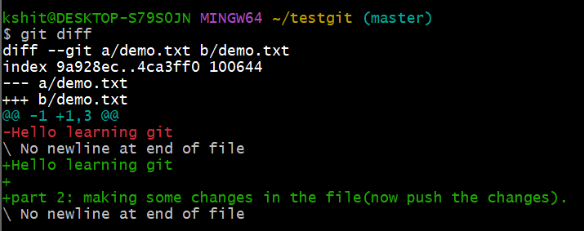

1. **Merge operation:**

* Create 3 more files: demo1.txt, demo2.txt, demo3.txt.

1. Main branch: master branch.
2. Create another branch named: first_branch.



1. Shift to the first_branch. All the files present in master branch will be present in the first_branch, since the new branch is derived from the main branch.
2. Add demo3.txt into the first_branch as a new file.

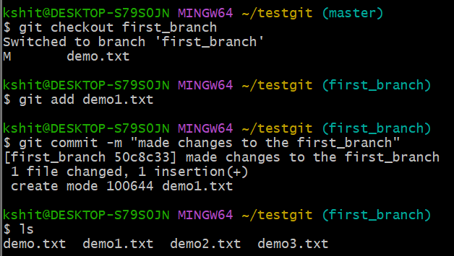

1. Before merging shift to the original branch i.e master branch.

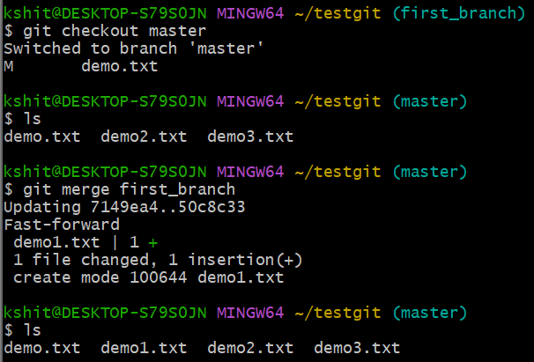

If main branch consists:

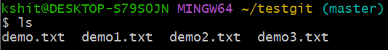

Then first_branch consist:

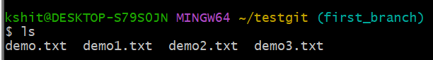

**CONCLUSION**

Also merge the branch. (summarized manner, created a new branch named child branch).

